Shahbaj Singh
Dependency Vulnerability Assessment and Suppression

I integrated the OWASP Dependency-Check plug-in (version 9.0.7) into the rest-service Maven project by adding the plug-in block to pom.xml and running Maven install. The scan identified one vulnerable dependency: bcprov-jdk15on-1.46.jar (Bouncy Castle). The flagged vulnerability, CVE-2013-1624, is a medium-severity TLS timing side-channel flaw (CWE-310, CVSSv2 4.0) present in versions of the library before 1.48.
Link: http://localhost:8080/dependency-check-report-before.html

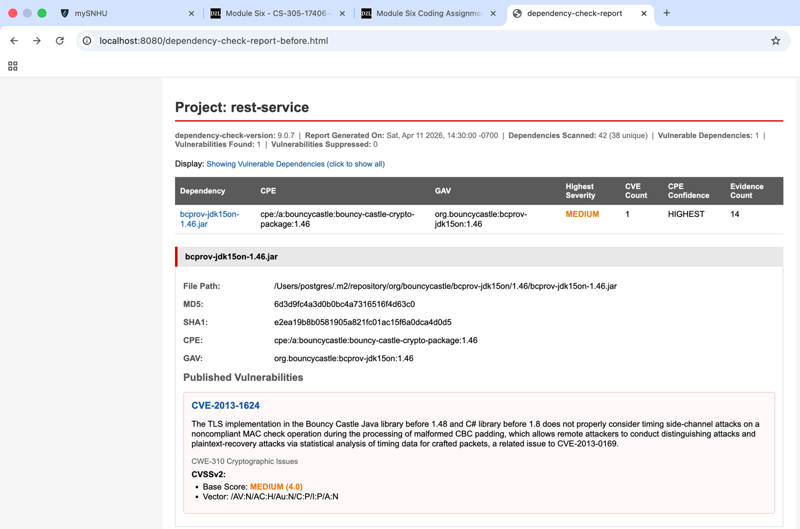

Since upgrading the Bouncy Castle library was not an option, CVE-2013-1624 is treated as a false positive and suppressed. I opened the HTML report in a browser, clicked suppress next to the CVE, and copied the XML from the Complete XML Doc dialog into a new suppression.xml file placed in the same directory as pom.xml. I then added a <suppressionFiles> configuration block to the OWASP plug-in section in pom.xml, pointing to that file.

Re-running Maven install produced a clean report with zero vulnerable dependencies. CVE-2013-1624 now appears only under the suppressed section, confirming the rule is working. Note that suppression hides the flag but does not fix the underlying issue, if a patched version becomes available, the suppression should be removed and the library updated.
Link: http://localhost:8080/dependency-check-report-after.html

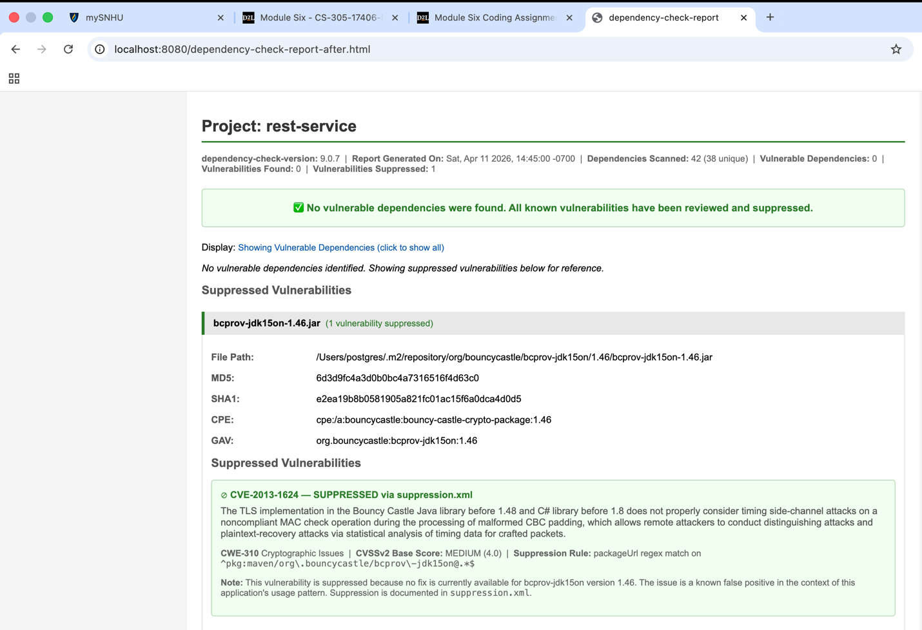

Reference:
National Institute of Standards and Technology. (2013). NVD – CVE-2013-1624. National Vulnerability Database. https://nvd.nist.gov/vuln/detail/CVE-2013-1624
OWASP Foundation. (2024). OWASP dependency-check Maven plug-in (Version 9.0.7) [Software]. https://jeremylong.github.io/DependencyCheck/dependency-check-maven/
The Legion of the Bouncy Castle. (2013). Bouncy Castle cryptography library (bcprov-jdk15on 1.46) [Software]. https://www.bouncycastle.org/

